DIAMOND FIBER LASER 2
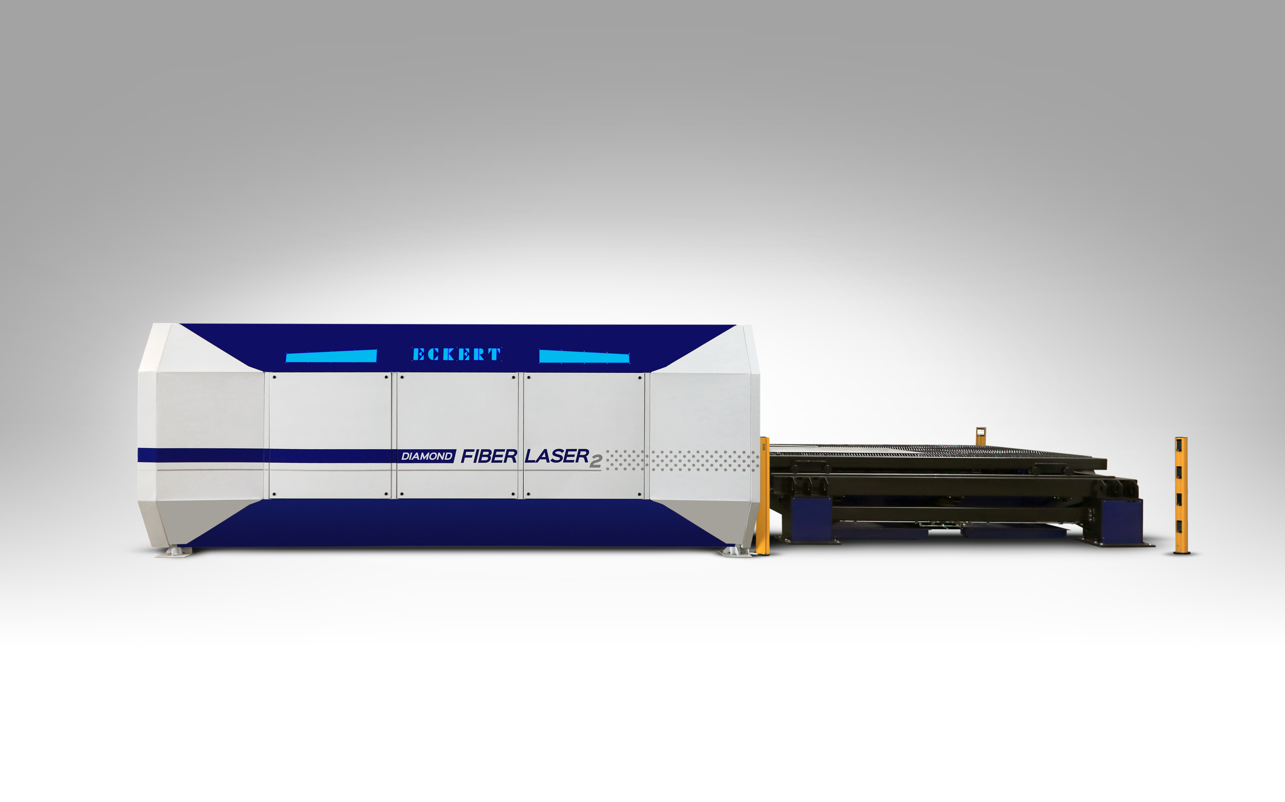

Diamond Fiber Laser 2 cutting machine that operates with a fiber laser technology. It is dedicated to users whose priority is speed and the highest cutting precision also in complicated contours. The utilization of fiber laser technology significantly decreases the complexity of laser system
and directly reduces operating costs compared to CO2 laser technology.

Individual consumer's needs are ensured by the application of compact gantry construction
that enhances stability, completely closed safety cabinet protecting against laser radiation
and capability of adjusting the working area dimensions.

MAIN FEATURES:
- Capability of processing a wide range of reflective materials (copper, brass, polished materials);
- Long-term reliability ensured by the highest quality components produced by renowned manufacturers;
- Innovative PCS system which is able to analyse and precisely select piercing time
with accordance to the material applied (OPTION);
- Optional instalment of linear drives instead of double servo-motors with anti-collision system;
- Fully automated cutting proces with load and unload of the plates (OPTION);

COMPOSITION OF THE MACHINE:

Laser source IPG YLS-4000 (4 kW)
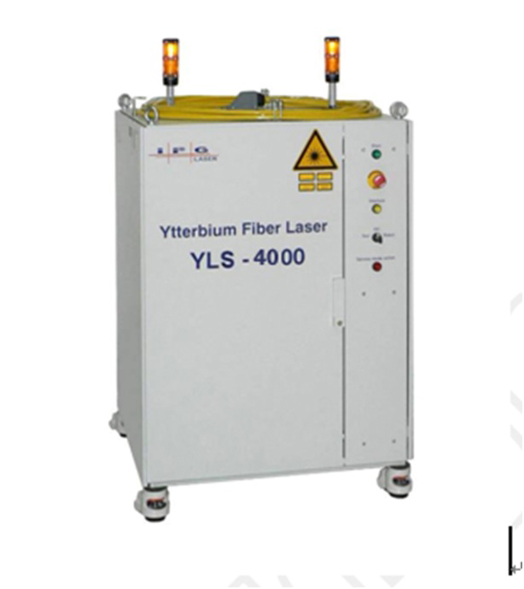

High power fiber lasers are created from active optical fibers
and semiconductor diodes, a merger between two of the most innovative and advanced laser technologies. Fiber lasers use single emiter semiconductor diodes as the light source to pump the active fibers. The laser beam emitted is contained within optical fibers and delivered through an armored flexible cable. Active fibers, special optical fibers doped with rare earth ions, allow
for an extremely bright light from a very small core, thus making possible the production of kilowatt class output with excellent beam quality. IPG uses many proprietary technologies
to create the undisputed best beam quality kilowatt class lasers available in the market today. The combination of technologies results in a unique, highly reliable and superior performing laser system with parameters exceeding any traditional laser technology, including disc, rod, YAG or CO2 lasers. Our robust fiber lasers share common attributes of compact size, long diode life, low maintenance operation, high wall plug efficiency and completely consistent beam divergence and beam profile at all power levels. IPG reliable fiber laser source
of modular construction has over 40% wall plug efficiency which gives the result of a three fold decrease in power consumption comparing to CO2 laser and estimated lifetime
is up to 100 000 working hours. All laser sources from YLS series have protection class IP52.

Cutting head PRECITEC

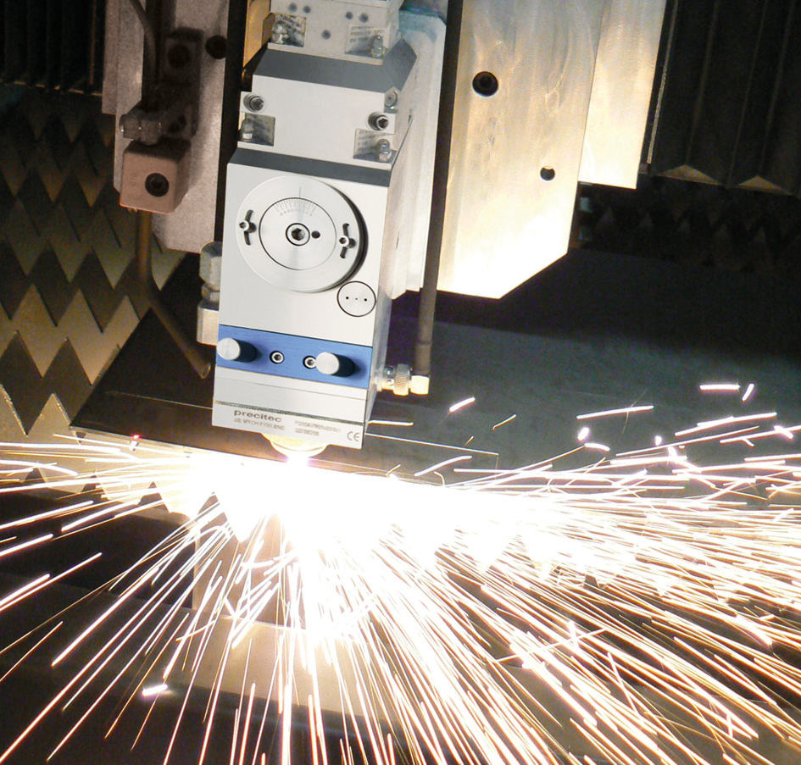
Precitec cutting head ensures exceptional reliability and cutting quality. Integrated distance sensor safeguards stability and prevents collisions. To protect its high grade optical components, this cutting head is fitted with a protective glass which is located in the cartridge. Optionally it is available innovative PCS system (Piercing Control System) which controls the laser beam emission to significantly increase the efficiency
and productivity.

CNC controller
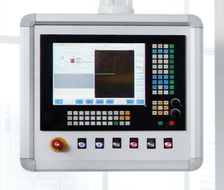
ECS872 centre is a high quality industrial device, equipped with touch screen. Efficient components and construction resistant to extreme production conditions guarantee failure free operation. Unsurpassed functionality of proprietary software and intuitive drive interface enable full exploitation of the machine’s capacity.

Cutting shuttle table 2000 x 4000 mm

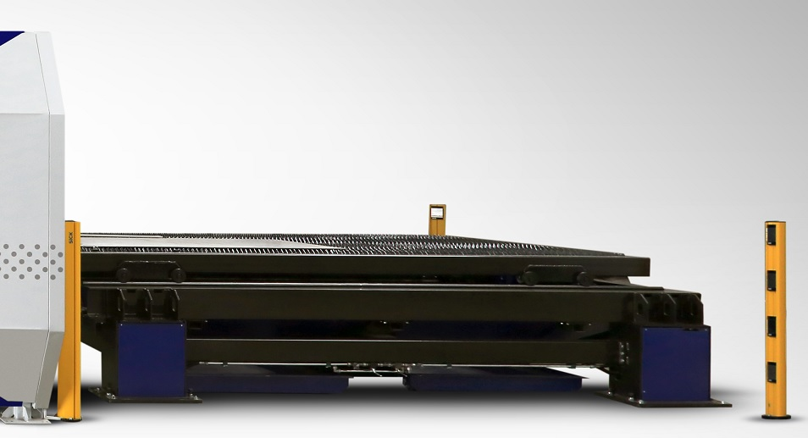
Exchangeable pallet table consists of two working areas which enable the possibility of alternate entering and departing the working area allowing the unloading of finished elements and loading new material. Pallet table is equipped with belt feeder responsible for collecting elements which are
to small to retain on the grate. The table is equipped with safety laser gates to realize the required safety
of work.

Filter unit PFC-4 (7,5 kW)

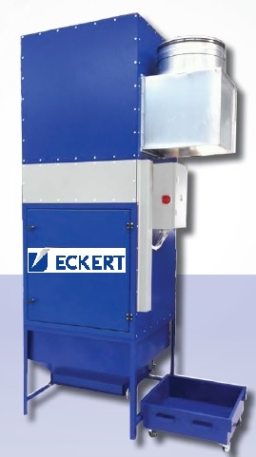
Filtroventilation system is used to eliminate potentially dangerous fumes
and dust by-products of thermal cutting operations. We offer models
with filter area within the range 80 to 240 m2 and efficiency
up to 15.000 m3/h. The optional spark extinguishing system guarantees damping down glowing embers and provides a longer lifetime of filter cartridges. The extensive suction system produced by Eckert, which efficiency is up to 99,99% meets all the necessary safety European standards.
This extremely efficient system is controlled with intuitive CNC panel.
The ventilation system has a self-cleaning module, which removes dust automatically using compressed air and additionally a teflon coating in filter cartridges extends their life time. Specially tuned solution enables to return the clean and warm air to the hall, so we get huge savings of thermal energy in winter. The system is selected according to the requirements of machine technical specification and customer requirements.

Auto Focus
The special system whch changes the focal length of the head automatically. The operator has to choose from the database in CNC controller ECS 872 the thickness and kind of material. Then machine automatically adjusts the focal length of the cutting head. Without this option, operator can see on the screen controller the value of the focal length and change it manually on the head using the special wheel.

PCS (Piercing Control System)

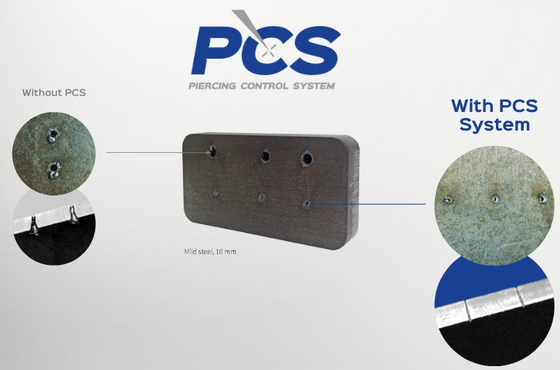
The innovative system that offers ECKERT company is based
on the electro-optical analysis of color and temperature of the piercing key hole. Using the acquired parameters LPM (Laser Power Monitor) takes control of the emission of the laser beam and prevents micro- explosions during the piercing
and limits slag on the top and bottom of the material.
Piercing the material without PCS system so far has been done using the maximum power of laser beam. This resulted
in overheating of the material at the point of piercing, and eruption of plasma, ejecting melted material towards the nozzle. Thus produced material spatters and explosions often caused contamination and sometimes damage to the nozzle and the laser protective lenses. The system
of PCS selects an appropriate power of the beam so that the temperature during the piercing has not reached a critical point. In addition, observation of light radiation emitted by the plasma during piercing fully control the advanced processes occurring on a focus spot of the laser beam.

Another equally important argument that speaks for the PCS system is the fact that this system will analyze and accurately set piercing time to the type of material. From experience, we can say that a plate of the same kind on the market may differ slightly from one another regarding composition or species. So far, every manufacturer of fiber laser cutting machines made permanent tables that set piercing time and laser beam power in advance. It was not time-efficient, and the quality of piercing was far away from the optimum. The big problem
was the heating of the sheet metal during cutting. Piercing of hot or very chilled plates using standard parameters determined by the manufacturer will almost always ended in explosions
or unfinished piercing. Therefore, producers estimated the time an overstatement piercing
to prevent it. The entire system is controlled by LPM (Laser Power Monitor) that with frequency
of several thousand times a second monitor and process the received data. In this way, in real time LPM is capable of tracking processes in the pierced material. The development of such
a solution was possible thanks to advances in electro-optical and laser technology.

Advantages of the system:
- a significant reduction of piercing time (piercing time is adjusted in real time to the material and is limited to the absolute minimum),
- significantly reducing cutting time the entire spreadsheet cutting time, so also electricity and cutting gases,
- due to the information about exact moment of accomplished piercing, the laser beam doesn’t destroy the cutting table,
- sheet is no longer contaminated with slag and spatter generated during the proces
of piercing,
- large increase in service life of protective filters and nozzles,
- detection of incorrect cutting process by continually monitoring the plasma level,

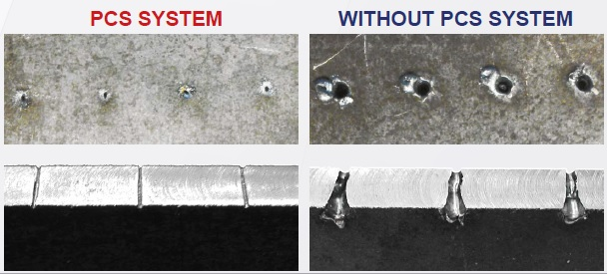

Air condition for CNC control panel and electrical box
Theese are the cooling devices to protect the CNC control panel and electrical box against
the overheating.

Automatic nozzle cleaning system
The controller function used during piercing of the materials of greater thickness and materials which generate higher dust density during piercing. The system provides automatic run command for cutting head to the zone in which the dynamic movements of the head over a specially arranged cleaning element removes dust that could appear on the outer surface of the cutting nozzle.

UPS for CNC controller and MEFI system
UPS is the safety power supply. The device is equipped with battery which stores the electricity taken from the mains. In case of power lost the device keeps the CNC controller running
and allows to close the program and shut down the machine.

CAD/CAM software Lantek Expert II
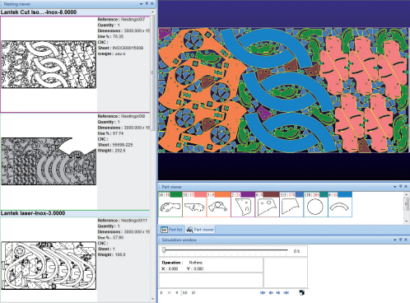
Lantek Expert II is a CAD / CAM system specially designed to automate the programming of sheet metal cutting machines (oxygen, plasma, laser, water jet). It is the result of more than 20 years of experience in close collaboration with both manufacturers and users of these types
of machines. It perfectly combines machine technology with customers’ programming and management requirements. Lantek Expert II is designed in such way,
so that users only have to follow the steps indicated
by the system. The software is very powerful
and to increase the programming efficiency it allows to programmer:
- pre-nesting,
- nesting via kits,
- maximum calculation time,
- to define and save several connected tasks and execute them with just one click: import, nesting, selection of formats, materials and thicknesses , generation of machining, printing reports, etc.

Spare parts
The composition of the machine includes following spare parts:
- nozzle (1.0 , 1.2, 1.5 , 1.8 , 2.0 , 2.5 , 3.0) – 5 sets of each dimension,
- ceramic part – 3 pieces,
- cleaning tissue (lens and mirror) – 500 pieces,
- spare hard disc contains system back up – 1 piece,

